CO2 ASSESSMENT TOOL – 2
Architecture Design Assignment Report
Smart Offshore Wind Farm Management Platform
Course Code : CSA1007
Course Title : Software Engineering
Submitted By
Manne Praneeth (192372310)
Faculty Name
Dr. P. Subramanian

Problem Statement
Smart Offshore Wind Farm Management Platform
Objectives
- Monitor turbine performance.
- Predict equipment failures.
- Optimize energy generation.
- Track weather conditions.
- Schedule maintenance activities.
- Generate operational analytics.
Expected Outcomes
- Reduced turbine downtime.
- Improved energy production.
- Lower maintenance costs.
- Enhanced grid reliability.
- Better asset utilization.
1. Analyze System Requirements
1.1 System Objectives
The Smart Offshore Wind Farm Management Platform is intended to provide continuous, data-driven oversight of an offshore wind installation. The system must collect real-time telemetry from turbines and environmental sensors, analyze this data to anticipate equipment failures, optimize the amount of energy generated under varying wind and sea conditions, and coordinate maintenance activities for technicians who operate under strict weather and safety windows. The platform therefore acts as the digital nervous system of the wind farm, connecting field sensors, predictive analytics, and human decision-making into a single operational workflow.
1.2 Functional Requirements
- Continuously acquire turbine performance data such as rotor speed, blade pitch, power output, vibration, and temperature.
- Analyze sensor and historical data to predict component wear and possible equipment failure.
- Recommend and apply control adjustments to optimize energy generation based on live wind and sea conditions.
- Integrate live weather and met-ocean data to support operational and safety decisions.
- Generate, assign, and track maintenance work orders and technician schedules.
- Produce dashboards and reports summarizing turbine health, energy yield, and maintenance history.
- Send real-time alerts and notifications for faults, threshold breaches, or unsafe conditions.
- Provide role-based access for operators, maintenance engineers, and grid-management staff.
1.3 Non-Functional Requirements
- Scalability to accommodate an increasing number of turbines, sensors, and data points as the farm expands.
- High availability, since offshore operations require near continuous monitoring with minimal downtime.
- Reliability of predictive alerts, as missed failure predictions can cause costly turbine outages.
- Low-latency processing for near real-time monitoring and control decisions.
- Strong security, since the platform connects to critical energy infrastructure and grid systems.
- Maintainability, allowing new analytics models and turbine types to be added with minimal disruption.
- Fault tolerance to handle intermittent offshore connectivity without losing data.
- Interoperability with SCADA systems, weather services, and grid-operator platforms.
1.4 Key Quality Attributes
Given the offshore and safety-critical nature of the system, the architecture must place the highest priority on scalability, reliability, availability, and security, while also supporting maintainability and performance. Scalability ensures new turbines and sensors can be incorporated as the farm grows; reliability and availability ensure that failure predictions and monitoring data remain trustworthy and continuously accessible despite harsh offshore conditions; security protects the platform from unauthorized access given its connection to national grid infrastructure; and maintainability and performance ensure the system can evolve and respond quickly as analytics models and operational needs change over time.
2. Select a Suitable Software Architecture
A Hybrid Architecture combining Microservices with an Event-Driven communication style is selected for the Smart Offshore Wind Farm Management Platform.
The platform receives continuous, high-volume streaming data from turbines and weather sensors, and must run several independent functions such as monitoring, predictive maintenance, energy optimization, and scheduling. A single monolithic system would make it difficult to scale individual functions independently or to update predictive models without redeploying the entire application. A purely layered or client-server style would also struggle to handle the asynchronous, high-frequency sensor streams that this system depends on.
Microservices allow each functional capability, such as predictive maintenance or energy optimization, to be developed, deployed, and scaled independently, which is important because these services have very different computational and scaling needs. An Event-Driven backbone, implemented using a message broker, allows sensor data to be published once and consumed by multiple services simultaneously, which suits the continuous and asynchronous nature of turbine telemetry far better than a request-response only design.
This hybrid approach was therefore chosen over alternatives such as a purely layered architecture (which is simpler but less scalable for independent services) and a purely event-driven or serverless design (which can complicate long-running analytics and maintenance-scheduling workflows). The hybrid model balances the responsiveness needed for real-time monitoring with the modularity and scalability needed for long-term operation of a growing offshore wind farm.

3. Software Architecture Diagram
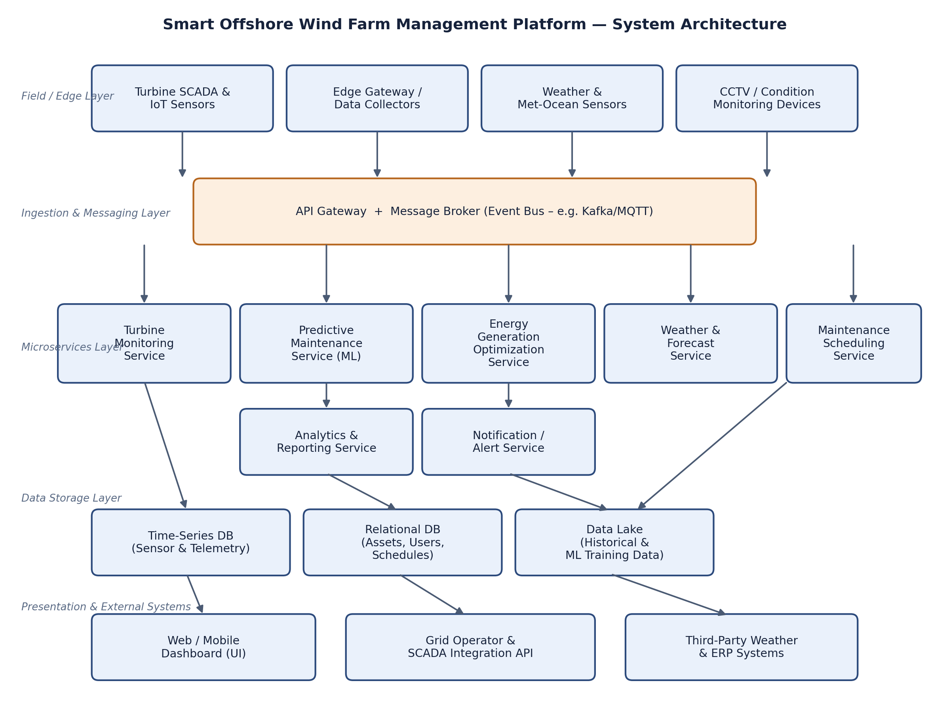
Figure 1: Layered microservices and event-driven architecture of the Smart Offshore Wind Farm Management Platform, showing the flow from field sensors through the message broker, microservices, storage, and presentation layers.
4. Explain Components and Their Interactions
4.1 Component Responsibilities
- Turbine SCADA and IoT Sensors: capture raw operational data such as rotor speed, vibration, temperature, and power output from each turbine.
- Edge Gateway / Data Collectors: aggregate and pre-process sensor readings offshore before transmitting them to the central platform.
- Weather and Met-Ocean Sensors: supply live wind speed, wave height, and weather data used for safety and optimization decisions.
- API Gateway and Message Broker: act as the single entry point for external requests and the event bus that streams sensor data to all subscribing services.
- Turbine Monitoring Service: continuously tracks turbine health indicators and flags abnormal readings.
- Predictive Maintenance Service: applies machine-learning models to historical and live data to forecast component failures.
- Energy Generation Optimization Service: adjusts turbine control parameters to maximize output under current wind conditions.
- Weather and Forecast Service: processes meteorological data to support safe operational planning.
- Maintenance Scheduling Service: converts predictive alerts into work orders and coordinates technician schedules.
- Analytics and Reporting Service: aggregates data across services to generate operational dashboards and reports.
- Notification / Alert Service: delivers real-time alerts to operators and maintenance teams.
- Data Storage (Time-Series DB, Relational DB, Data Lake): persist telemetry, operational records, and historical data used for reporting and model training.
- Web / Mobile Dashboard: presents monitoring data, alerts, and reports to operators and engineers.
- Grid Operator and Third-Party Integrations: exchange energy production data and weather information with external systems.
4.2 Overall Workflow
Sensor readings from turbines and weather stations are collected at the edge and published to the message broker. Subscribing microservices consume these events independently and in parallel: the monitoring service updates turbine health status, the predictive maintenance service evaluates failure risk, and the energy optimization service recalculates optimal control settings. When the predictive maintenance service detects a rising failure risk, it raises an event that is picked up by the maintenance scheduling service, which creates a work order and by the notification service, which alerts the relevant technician. All processed data is persisted in the appropriate data store and made available to the analytics service, which powers the dashboards viewed by operators, while selected production data is also shared with grid-operator systems through the API gateway.
5. Discuss Quality Attributes
5.1 Scalability
The microservices design allows each service, such as predictive maintenance or monitoring, to be scaled independently based on load, and the event-driven message broker allows new turbines or sensors to be added by simply introducing new event producers without redesigning existing services.
5.2 Security
The API gateway centralizes authentication and access control, while role-based access restricts sensitive operations, such as grid integration or maintenance scheduling, to authorized personnel. Communication between edge devices and the platform is encrypted to protect critical energy-infrastructure data.
5.3 Performance
Time-series databases are used for high-frequency telemetry, allowing rapid writes and queries, while the event-driven backbone ensures that monitoring and optimization services respond to sensor data with minimal delay, which is essential for near real-time turbine control.
5.4 Reliability
Independent microservices isolate faults, so an issue in one service, such as the analytics module, does not directly affect critical functions like turbine monitoring or safety alerts. Message durability in the event bus also ensures that data is not lost during temporary service outages.
5.5 Maintainability
Because each microservice has a clearly defined responsibility, predictive-maintenance models, optimization algorithms, or scheduling rules can be updated and redeployed independently, without requiring changes to unrelated parts of the system.
5.6 Availability
Offshore connectivity can be intermittent, so edge gateways buffer data locally and forward it once connectivity is restored, and multiple service instances can be deployed to avoid single points of failure, ensuring continuous monitoring of the wind farm.
6. Justify Architectural Decisions
The hybrid microservices and event-driven architecture was selected because it directly matches the operational profile of an offshore wind farm: continuous, high-volume sensor streams; multiple independent analytical functions; and the need for both real-time responsiveness and long-term scalability. Compared to a monolithic or purely layered design, this approach allows individual services, such as predictive maintenance, to be improved or scaled without impacting the rest of the system.
The main trade-off of this architecture is the increased operational complexity of managing multiple services and a message broker compared to a single application, along with the need for careful monitoring of inter-service communication. However, this complexity is justified by the benefits gained in scalability, fault isolation, and the ability to evolve individual components independently, which are essential for a safety-critical, continuously operating offshore system.
This architecture also supports future enhancements such as the addition of new turbine types, new predictive models, or additional third-party integrations, since new microservices can subscribe to existing event streams without disrupting current operations. This makes the platform well suited for long-term maintainability and for the continued growth of the offshore wind farm.

